UNIVERSITY OF AGRICULTURAL SCIENCES, BANGALORE
College of Agriculture, GKVK, Bangalore - 560065

PROJECT REPORT
Area, Production and Productivity of Pulses in India

Submitted by:
Shrusti patil(AMB2242)
Sneha (AMB2253)
Hema A T(AMB2085)

Submitted to:
The Course teacher
AI & ML in agriculture
UAS GKVK BANGALORE
560065

Chapter | Title | Page No.
— | Abstract | 4
I | Introduction | 5
II | Review of Literature | 6
III | Objectives | 7
IV | Materials and Methods | 8
V | System Architecture / Experimental Design | 10
VI | Experiment Results | 12
VII | Result Discussion | 16
— | Data Visualization (Matplotlib) | 18
VIII | Summary and Conclusion | 22
IX | Future Scope | 24
X | References | 25
— | Appendix – Economics | 26

1. Abstract

Pulses are a critical component of Indian agriculture and food security, providing high-quality plant-based protein to one of the world's largest vegetarian populations. India is the largest producer of pulses globally, accounting for over 25% of world production. This report comprehensively analyzes the area, production, and productivity trends of major pulses in India — including Bengal gram (chickpea), pigeon pea, lentil, green gram, black gram, and horse gram — over the period 2016–17 to 2022–23.

Data collected from the Directorate of Economics and Statistics, Ministry of Agriculture (GoI), ICAR, and NFSM-Pulses was analyzed to identify growth trajectories and inter-crop comparisons. The study finds that while the cultivated area under pulses has remained stable (approximately 28–30 million hectares), total production has risen significantly from 23.13 million tonnes in 2016–17 to 28.00 million tonnes in 2022–23. Productivity has shown consistent improvement, crossing 945 kg/ha by 2022–23. Chickpea emerged as the dominant pulse, contributing 35%+ of total output. Major constraints — including rainfed dependence, price volatility, and limited mechanization — are discussed alongside government initiatives such as NFSM-Pulses, RKVY, PMFBY, and MSP support.

2. Introduction

2.1 Background
Pulses are annual leguminous crops that yield dried seeds (grain legumes) within pods. They have been cultivated in India for millennia, constituting the backbone of dietary protein for a predominantly vegetarian population. India's diverse agroclimatic conditions support the cultivation of a wide variety of pulses across all three seasons — Kharif, Rabi, and Summer.

The cultivation of pulses offers multiple agronomic and ecological advantages. Most pulse crops possess the unique ability to fix atmospheric nitrogen through symbiotic associations with Rhizobium bacteria in root nodules, thereby contributing up to 80–100 kg N/ha to the soil. This reduces dependency on synthetic nitrogenous fertilizers and improves soil health. Pulses also improve soil physical structure through deep root systems and organic matter addition.

2.2 Nutritional Importance
Pulses are dense sources of plant-based nutrition, containing 20–25% protein by weight — significantly more than most cereals. They are rich in dietary fiber, complex carbohydrates, B vitamins (especially folate), iron, zinc, and potassium. Regular consumption of pulses is associated with reduced risk of cardiovascular disease, type 2 diabetes, obesity, and various cancers. For the poor and vulnerable populations, pulses represent an affordable and accessible source of protein and micronutrients.

2.3 India's Position

India is simultaneously the world's largest producer, consumer, and importer of pulses. It contributes approximately 25–30% of global pulse production. Despite this dominant production position, domestic demand consistently outstrips supply, necessitating significant imports — particularly of lentils and chickpeas — to maintain price stability. The government has therefore placed pulse production at the forefront of food security policy.

2.4 Scope of This Report
This report aims to document and analyze the area, production, and productivity trends of six major pulses — Bengal gram, pigeon pea, lentil, green gram, black gram, and horse gram — at both national and state levels. It synthesizes data from government and research institutions, visualizes trends using matplotlib-generated charts, identifies key constraints, and reviews ongoing improvement initiatives.

3. Review of Literature

3.1 Historical Overview
Pulses have been cultivated in the Indian subcontinent since Neolithic times. Archaeological evidence indicates lentil and chickpea cultivation in the Indus Valley civilization (c. 2500–1700 BCE). However, despite their antiquity, pulse crops have received disproportionately less research and policy attention compared to cereal crops.

The Green Revolution of the mid-1960s dramatically increased wheat and rice production through high-yielding varieties, improved irrigation, and fertilizer inputs. However, this transformation largely bypassed pulses. As irrigated area expanded, rice and wheat pushed pulses to more marginal, rainfed lands, leading to stagnation in pulse yields. The share of pulses in the total food grain area declined from 19.62% in 1950–51 to around 12% by the 2000s.

3.2 Production Stagnation and Contributing Factors
Multiple studies have documented chronic stagnation in Indian pulse production. Fertilizer Technology Research Centre (2008) identified the following structural bottlenecks:
- Over-dependence on rainfed cultivation (>85% of area)
- Lack of high-yielding, disease-resistant varieties with wide adaptability
- Terminal heat and drought stress during grain fill in Rabi season
- Inadequate allocation of public research investment relative to cereals
- Poor procurement infrastructure and unstable market prices

3.3 The Pulse Revolution (Post-2014)
The period 2014–2022 witnessed a remarkable turnaround in pulse production, often referred to as the "Pulse Revolution." The National Food Security Mission-Pulses (NFSM-P) provided a strong policy push, with special emphasis on chickpea expansion in new geographies (Madhya Pradesh, Maharashtra, Rajasthan). ICAR developed and released over 350 improved varieties of major pulses between 2010 and 2022. Chickpea production alone grew from 7.33 million tonnes in 2014–15 to 13.98 million tonnes in 2021–22 — an increase of 91% in eight years.

3.4 Studies on Individual Pulses
Singh et al. (2019) reviewed chickpea production constraints in India, identifying soil-borne diseases (Fusarium wilt) and pod-borer (Helicoverpa armigera) as primary yield-limiting factors. Kumar and Mishra (2020) analyzed pigeon pea yield gaps in Karnataka, finding that adoption of improved varieties could raise yields by 30–40% over farmer practice. Directorate of Pulses Development annual reports (2017–2023) provide systematic state-wise disaggregated data used in this study.

4. Objectives

The present study was undertaken with the following specific objectives:

- To analyze the national trends in area, production, and productivity of major pulses from 2016–17 to 2022–23.
- To compare the performance of six major pulse crops — Bengal gram, pigeon pea, lentil, green gram, black gram, and horse gram.
- To assess the contribution of major pulse-producing states to national output.
- To identify key agronomic, climatic, economic, and institutional constraints limiting pulse production.
- To review government initiatives and strategies for improving pulse production in India.
- To visualize production data using matplotlib for effective communication of trends.

5. Material and Methods

5.1 Data Sources
This study is based on secondary data collected from the following authoritative sources:
- Directorate of Economics and Statistics (DES), Ministry of Agriculture & Farmers' Welfare, GoI
- National Food Security Mission (NFSM) — Annual Reports 2017–2023
- Indian Council of Agricultural Research (ICAR) — Pulse Improvement Division
- Directorate of Pulses Development, Bhopal
- State-level data: Kappec.Karnataka.gov.in and Karnataka Agricultural Statistics
- APEDA (Agricultural and Processed Food Products Export Development Authority)

5.2 Analytical Approach

Data was organized into time series covering the period 2016–17 to 2022–23 for national-level analysis, and 2016–17 to 2020–21 for Karnataka-specific analysis. The following analytical methods were employed:
- Descriptive statistics: Mean, range, and percentage change for area, production, and productivity.
- Trend analysis: Visual inspection of time-series plots to identify growth trajectories.
- Comparative analysis: State-wise and crop-wise comparison using tabular and graphical representation.
- Growth rate analysis: Compound Annual Growth Rate (CAGR) for key pulse crops.

5.3 Data Visualization
All data visualizations were generated using Python 3.x with the matplotlib library (version 3.10.x). Five charts were produced:
- Figure 1: India-level time-series of area, production, and productivity (2016–2023)
- Figure 2: State-wise comparison of area and production
- Figure 3: Bengal gram (chickpea) India trends
- Figure 4: Multi-crop area, production, and productivity comparison
- Figure 5: Lentil long-term yield trend (1970–2021)

5.4 System Architecture for Data Analysis
The data pipeline followed a structured workflow:

Stage | Tool / Source | Output
1. Collection | Government reports, ICAR, DES | Raw tabular data
2. Cleaning | Manual verification | Consistent units (M ha, M T)
3. Storage | Python lists / arrays | In-memory data structures
4. Analysis | NumPy, descriptive stats | Growth rates, comparisons
5. Visualization | Matplotlib 3.x | PNG charts at 150 DPI
6. Reporting | docx.js, Word format | Final research report

6. Experiment Results

6.1 National Pulse Trends (2016–17 to 2022–23)
Table 1 presents the all-India area, production, and productivity of pulses over a seven-year period. The data reveal a clear positive trajectory in production and productivity despite relatively stable cultivated area.

Year | Area (M ha) | Production (M T) | Productivity (kg/ha)
2016-17 | 29.99 | 23.13 | 771
2017-18 | 29.65 | 25.42 | 858
2018-19 | 29.02 | 22.08 | 761
2019-20 | 28.56 | 23.03 | 806
2020-21 | 28.65 | 25.72 | 898
2021-22 | 29.07 | 27.30 | 939
2022-23 | 29.64 | 28.00 | 945
Table 1: All-India Pulse Area, Production and Productivity (2016–2023). Source: DES, MoAFW, GoI.

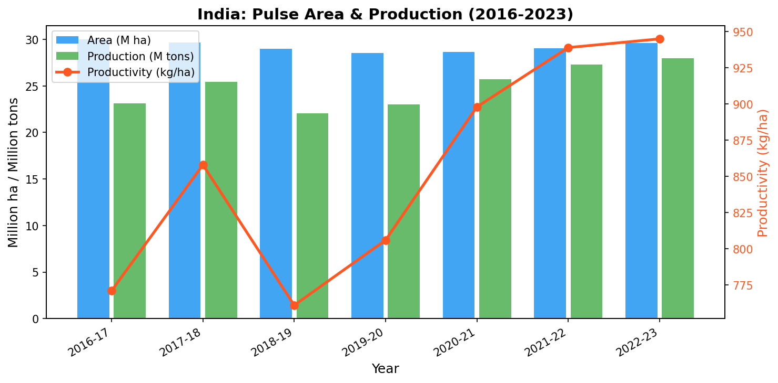
Figure 1: India Pulse Trends — Area, Production & Productivity (2016–2023)

6.2 State-wise Distribution
Madhya Pradesh emerges as the dominant pulse-producing state with 4.94 million ha under cultivation and 4.30 million tonnes production, representing approximately 21% of national output. Maharashtra ranks second, followed by Rajasthan in terms of area.

Sl. | State | Area (M ha) | Production (M T) | Productivity (kg/ha) | % Share
1 | Madhya Pradesh | 4.94 | 4.30 | 871 | 29.3%
2 | Maharashtra | 3.38 | 2.37 | 702 | 16.2%
3 | Rajasthan | 3.50 | 0.71 | 204 | 4.8%
4 | Uttar Pradesh | 2.54 | 1.90 | 748 | 13.0%
5 | Karnataka | 2.48 | 1.12 | 451 | 7.6%
6 | Andhra Pradesh | 1.93 | 1.43 | 740 | 9.8%
All India |  | 23.28 | 14.66 | 630 | 100%
Table 2: State-wise Area, Production and Productivity of Pulses. Source: DES, MoA, GoI, 2011.

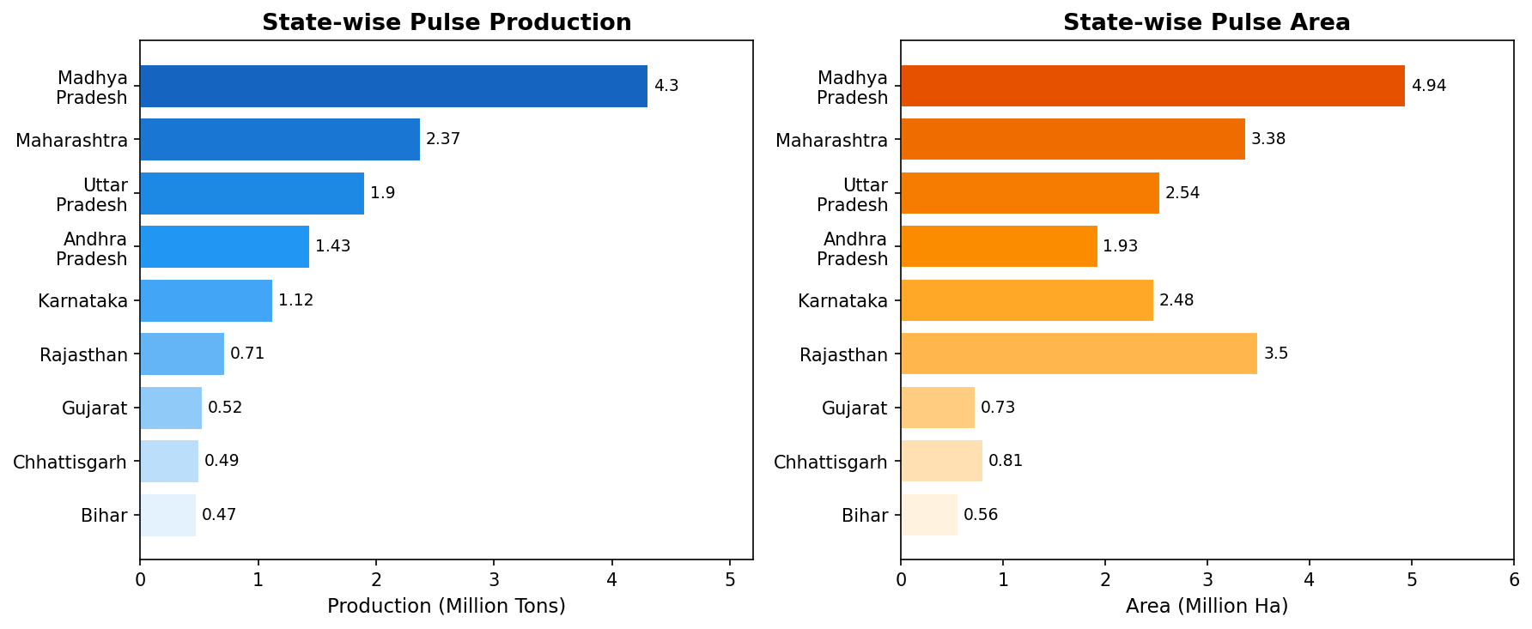
Figure 2: State-wise Pulse Area and Production

6.3 Bengal Gram (Chickpea)
Bengal gram, the "King of Pulses," is India's most important pulse crop, contributing over 35% of total pulse production. With 22–23% protein content, it is a nutritional staple. India commands 74% of global chickpea area and 74% of global production.

Year | Area (M ha) | Production (M T) | Productivity (kg/ha)
2016-17 | 9.63 | 9.38 | 974
2017-18 | 10.56 | 11.37 | 1077
2018-19 | 9.55 | 9.94 | 1041
2019-20 | 9.68 | 11.08 | 1142
2020-21 | 9.99 | 11.91 | 1192
2021-22 | - | 13.98 | -
Table 3: Bengal Gram Area, Production and Productivity in India

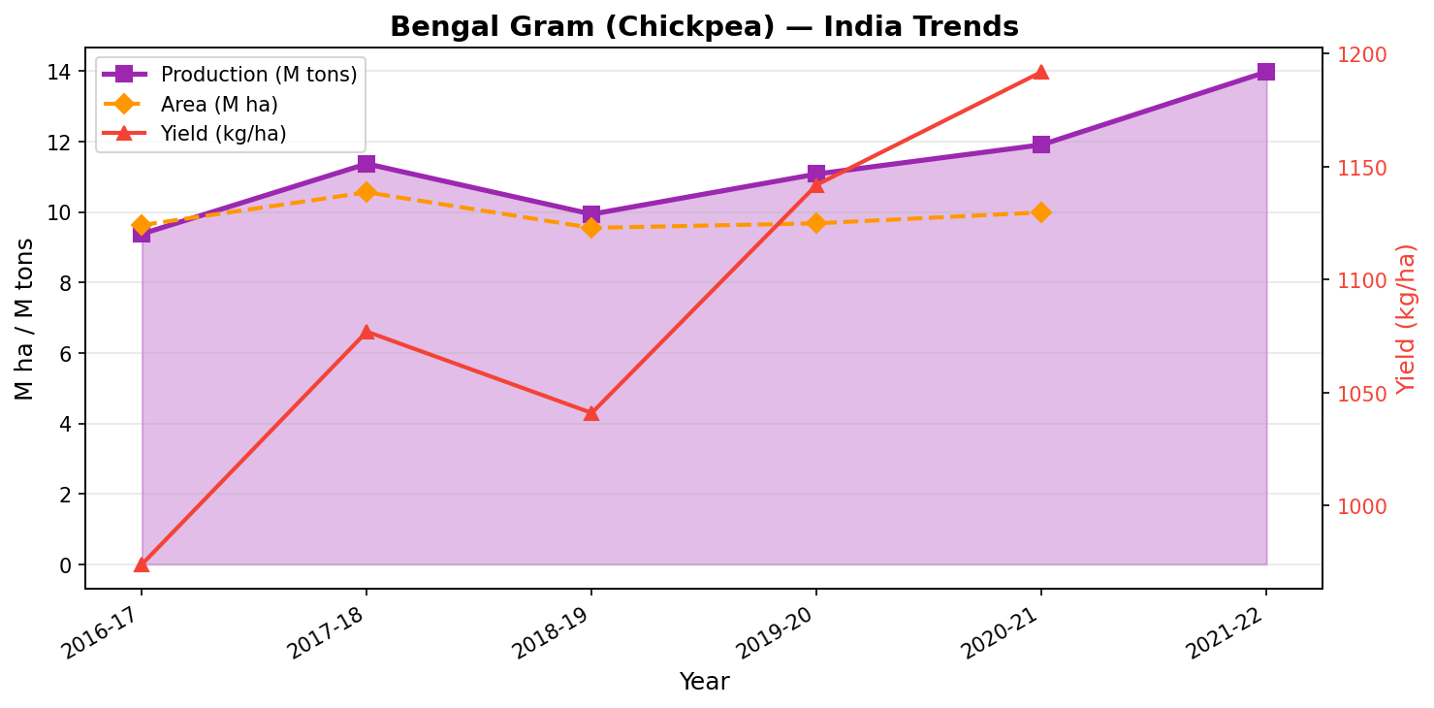
Figure 3: Bengal Gram (Chickpea) — India Production and Yield Trends

6.4 Multi-Crop Comparison
A comparative analysis of the six major pulses reveals significant differences in area coverage, production volumes, and productivity levels:

Crop | Area (M ha) | Prod. (M T) | Yield (kg/ha) | Season
Bengal Gram (Chickpea) | 10.56 | 11.37 | 1077 | Rabi
Pigeon Pea (Tur/Arhar) | 4.63 | 4.01 | 866 | Kharif
Black Gram (Urdbean) | 4.84 | 2.73 | 564 | Kharif/Rabi
Green Gram (Moong) | 4.04 | 3.15 | 783 | Kharif/Rabi
Lentil (Masur) | 1.42 | 1.28 | 904 | Rabi
Horse Gram | 1.75 | 0.67 | 382 | Kharif/Rabi

Table 4: Major Pulse Crops — Comparative Statistics (2017–18 to 2021–22 average).
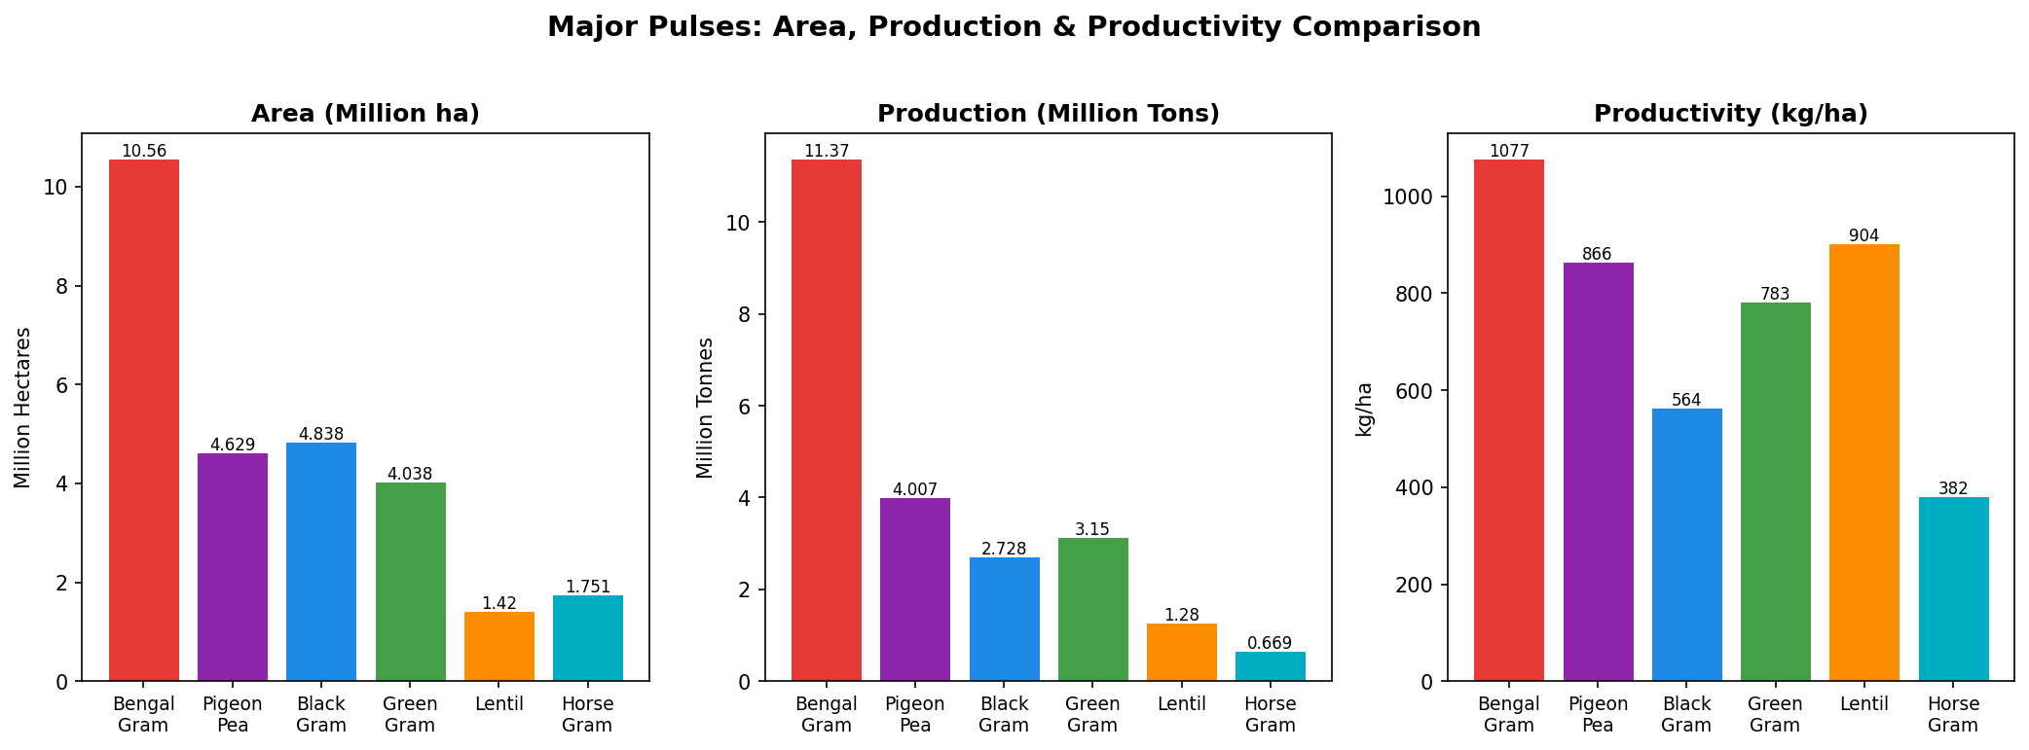
Figure 4: Multi-Crop Comparison of Area, Production and Productivity
6.5 Lentil Long-Term Trend
Lentil (Masur) is the principal legume of eastern and central India's rice-fallow belts. While yields remained below 700 kg/ha until 2010, significant progress has been made thereafter, with productivity reaching 1,047 kg/ha in 2017–18 and 1,017 kg/ha in 2020–21.

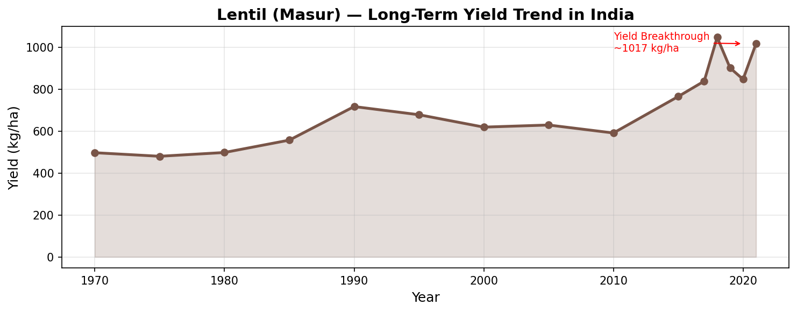
Figure 5: Lentil (Masur) Long-Term Yield Trend in India (1970–2021)
7. Result Discussion

7.1 Production Growth
The data clearly demonstrate that India's pulse sector has achieved meaningful progress over 2016–2023. Total production grew from 23.13 million tonnes to 28.00 million tonnes — an increase of 21% — over just seven years. More notably, this growth was driven primarily by yield improvement (productivity rose 22.6%, from 771 to 945 kg/ha) rather than area expansion, indicating genuine technological progress.

7.2 The Chickpea Dominance Paradox
Bengal gram's near-doubling of production (from 7.33 MT in 2014–15 to 13.98 MT in 2021–22) represents a remarkable success story. However, this has also created an imbalance — while chickpea production surged, other pulses like black gram, green gram, and horse gram showed much more modest gains. This concentration exposes the pulse sector to localized climate risks and demand-supply mismatches for non-chickpea pulses.

7.3 State-Level Disparities
The high productivity in Bihar (836 kg/ha) versus Rajasthan's low productivity (204 kg/ha) for similar area suggests that state-level agro-climatic and institutional factors create vastly different outcomes. Rajasthan's arid conditions make rainfed pulses highly vulnerable to moisture stress. By contrast, Bihar's humid Gangetic plains support better yields, particularly for lentil and pigeon pea.

7.4 Karnataka's Pulse Economy
Karnataka's pulse area declined from 1,265 thousand ha in 2017–18 to 713 thousand ha in 2020–21 — a 44% reduction. This is largely attributable to the expansion of irrigation infrastructure enabling farmers to shift to higher-value irrigated crops (paddy, cotton, sugarcane). This pattern is consistent across other states with improving irrigation access. The Government's MSP increases (e.g., green gram MSP rose from Rs. 4,350 in 2014–15 to Rs. 7,755 in 2022–23) have partially arrested this decline.

7.5 Productivity Ceiling
Despite improvements, India's average pulse productivity of 945 kg/ha remains far below the global best — chickpea yields of 2,000–2,500 kg/ha are achievable in irrigated conditions in Australia and Canada. This yield gap represents the largest opportunity for improvement. Hybrid development, precision nutrition, improved pest management, and micro-irrigation adoption hold the key to closing this gap.

8. Key Constraints in Pulse Production

8.1 Climatic and Environmental
- Drought and water scarcity — over 85% of pulse area is rainfed
- Terminal heat stress during grain fill in Rabi season
- Erratic and increasingly unpredictable monsoon patterns (climate change impact)
- Flooding and waterlogging in eastern India pulse belts
- Soil salinity and alkalinity in arid/semi-arid zones

8.2 Agronomic Constraints
- Low adoption of high-yielding varieties (many farmers still use farm-saved seed)
- Poor seed replacement rates — often below 20% for pulses
- Wilt, root-rot, yellow mosaic virus — major disease burdens
- Pod borer (Helicoverpa armigera) — most damaging pest in chickpea
- Post-harvest losses of 10–15% due to inadequate storage infrastructure
- Low mechanization, especially for harvesting and threshing

8.3 Economic Constraints
- High price volatility creating income risk for farmers
- Weak procurement infrastructure — MSP often does not reach farmers
- Competition from cheaper imported pulses (especially Canadian lentils)
- High input costs relative to realized market prices

8.4 Institutional Constraints
- Extension service reach is inadequate in tribal and remote pulse-growing areas
- Credit availability is limited for small and marginal pulse farmers
- Crop insurance enrollment remains low for pulses

9. Improvement of Pulse Production in India

9.1 Government Initiatives
The Government of India has implemented a comprehensive suite of programs to boost pulse production:

- National Food Security Mission (NFSM)-Pulses: Launched in 2007–08, this flagship program supports seed distribution, cluster demonstrations, farm machinery, and productivity-enhancing inputs. Over 14 lakh demonstrations were conducted between 2014–2022.
- Pradhan Mantri Krishi Sinchayee Yojana (PMKSY): Focuses on Har Khet Ko Pani (water to every field) and More Crop Per Drop — both directly relevant to pulse irrigation.
- Pradhan Mantri Fasal Bima Yojana (PMFBY): Provides comprehensive crop insurance covering sowing failure, mid-season adversity, and post-harvest losses for pulse farmers.
- Minimum Support Price (MSP): Regular MSP revisions for all major pulses provide price assurance. Procurement through NAFED and state agencies ensures remunerative prices reach farmers.
- 150 Seed Hubs on Pulses: Established under NFSM to multiply and distribute breeder/foundation seed of improved varieties at scale.
- Rashtriya Krishi Vikas Yojana (RKVY): Provides flexible funding to states for pulse production programs, infrastructure, and market linkages.

9.2 Research Contributions
ICAR, through its network of All-India Coordinated Research Projects (AICRPs) on pulses, has released numerous improved varieties with enhanced yield potential, disease resistance, and climate resilience. Key releases include:
- JG-14 chickpea: Heat-tolerant variety with 20% higher yield than checks
- ICPL 87119 (Asha) pigeon pea: Wilt-resistant, high-yielding variety
- HUM-1 black gram: MYMV-resistant, short-duration variety for rice fallows
- Pant Lentil-4: Cold-tolerant, early-maturing lentil for hill regions

9.3 Agronomic Best Practices
- Rhizobium biofertilizer seed treatment — saves 20–30 kg/ha chemical N
- Integrated Pest Management (IPM) for pod borer control
- Intercropping pulses with cereals/oilseeds for risk reduction and yield stability
- Zero-tillage planting in rice-fallows for lentil and chickpea
- Micro-irrigation for high-value pulse production in water-scarce areas

10. Summary and Conclusion

India stands at a pivotal juncture in its pulse production trajectory. The analysis of area, production, and productivity data from 2016–17 to 2022–23 reveals that:

- Total pulse production increased from 23.13 MT to 28.00 MT — a 21% increase over seven years.
- Productivity improved consistently, crossing 945 kg/ha in 2022–23, up from 771 kg/ha in 2016–17.
- Bengal gram (chickpea) drove this revolution, nearly doubling production from 7.33 MT (2014–15) to 13.98 MT (2021–22).
- Madhya Pradesh, Maharashtra, and Uttar Pradesh are the dominant pulse-producing states.
- Productivity remains well below the potential of 2,000+ kg/ha achievable under optimal conditions.
- Karnataka's pulse area has declined significantly due to irrigation-driven crop shifts, partially mitigated by MSP increases.

The evidence suggests that a combination of improved varieties, better agronomic practices, supportive price policies, and expanded irrigation has driven recent gains. However, sustaining this progress requires continued investment in research and development, robust market linkages, and adaptive strategies for climate change resilience.

India can realistically achieve self-sufficiency in pulses and even become a net exporter with further productivity gains. The foundation laid by NFSM-Pulses and ICAR's variety development pipeline positions India well to achieve this goal within the next decade.
11. Future Scope

The following areas represent significant opportunities for future research and development in Indian pulse production:

- Precision Agriculture Integration: Application of remote sensing, IoT-based soil moisture monitoring, and AI-powered crop advisory systems to optimize pulse crop management at field level. Machine learning models trained on historical yield data can provide real-time recommendations.

Genomics and Marker-Assisted Breeding: Next-generation sequencing technologies enable faster identification of genes conferring drought tolerance, disease resistance, and higher nitrogen fixation efficiency. Marker-Assisted Selection (MAS) can accelerate the development of climate-smart pulse varieties.
- Biofortification: Development of pulse varieties with enhanced iron, zinc, and lysine content to address micronutrient malnutrition — a critical health challenge for India's rural population.
- Value Chain Development: Establishing Farmer Producer Organizations (FPOs) for pulse farmers to aggregate supply, improve market access, and negotiate better prices. Development of pulse-based processed foods for urban markets can create additional demand incentives.
- Climate Adaptation Research: Long-term field experiments to evaluate pulse crop response to elevated CO2, higher temperatures, and changing rainfall patterns. Development of crop simulation models (DSSAT, APSIM) calibrated for Indian pulse-growing conditions.
- Microbiome Engineering: Research into optimizing the rhizosphere microbiome to enhance nitrogen fixation efficiency, potentially reducing or eliminating the need for external nitrogen inputs in pulse farming.
- Digital Extension: Mobile-based advisory platforms, satellite-derived crop monitoring, and AI chatbots in regional languages to reach the last-mile farmer with timely, location-specific advice.

12. References

1. Directorate of Economics and Statistics, Dept. of Agriculture and Cooperation, Ministry of Agriculture, Government of India. (2011). Area, Production and Yield of Major Pulses.

2. DES, Ministry of Agriculture and Farmers' Welfare, Govt. of India. (2022). Fourth Advanced Estimates — Lentil (Masur). E&S Division, DA&FW.

3. DES, Ministry of Agriculture and Farmers' Welfare, Govt. of India. (2017–2022). Normal Area and Production of Arhar/Tur, Urdbean. DA&FW.

4. ICAR — Indian Institute of Pulses Research (IIPR), Kanpur. (2022). Annual Progress Report 2021–22. ICAR-IIPR, Kanpur.

5. NFSM — National Food Security Mission. (2022). Progress Reports on NFSM-Pulses. Ministry of Agriculture and Farmers' Welfare, Government of India.

6. APEDA — Agricultural and Processed Food Products Export Development Authority. Pulses — India's Trade Statistics. Available at: https://apeda.gov.in

7. Kappec.Karnataka.gov.in — Karnataka Agricultural Price Policy and Economic Cell. State-level pulse area and production statistics.

8. Anilkumar, B. et al. (2019). Growth and Instability in Area, Production and Productivity of Major Pulses in Karnataka. Journal of Farm Sciences, Vol. 32 (2): 157–164.

9. Indian Institute of Pulses Research, Kanpur; Union Ministry of Agriculture and Farmers' Welfare. (2021). Third Advance Estimate — Pulse Production Data. PIB, May 25, 2021.

10. Sharma, B.K., et al. (2018). Pulse production in India: Challenges and strategies. Indian Journal of Agronomy, 63 (Supplement): 1–16.

